Ravan Muradzada
Contents
NFS 1
Task 1 1
Server Side 1
Client Side 2
Task 2 3
Server Side 3
Client Side 3
NTP 4
Task 1 4
Server Side 5
Client Side 5

NFS

Task 1

Server Side
Let’s install nfs-utils package in server side:
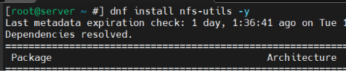
Let’s add these services to firewall permanently:
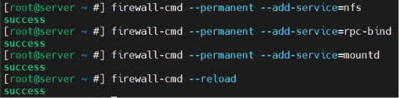
Let’s create a shared directory:
Then we should update /etc/exports file:
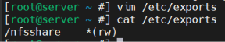
Let’s enable and start the service:

Client Side
Initially we should download the package here, too:
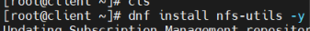
Now we can check whether any directory is shared or not by entering server’s IP:
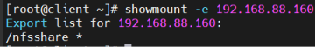
Let’s create a mountpoint:
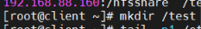
We need to open /etc/fstab file and add a line here:
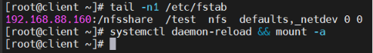
Now we enable and start the service:
When we check our /test directory in client side:
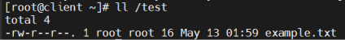
The file is from server.

Task 2

Server Side
First let’s design server side:
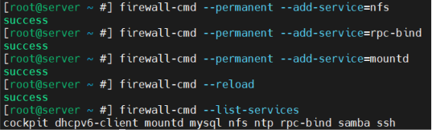
Let’s create a directory and add a line to /etc/exports:
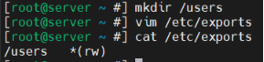
Then enable and start the services:

Client Side
Let’s download the packages:
Then we open this file:
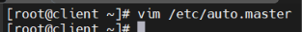
And add this:
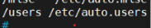
Then create `/etc/auto.users` file and add this:
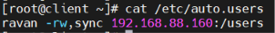
The ip is the ip of server.
When we check:
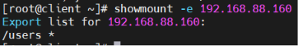
Now let’s enable and start the services:
Now let’s check:
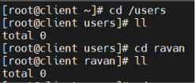
As you can see, initially there is no directory named `ravan` inside `/users`. When I run `cd ravan`, it is auto created and even if switched to this directory.

NTP

Task 1

Server Side
Timezone:
Let’s download the package and enable and start its service:
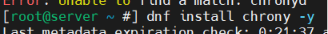
We should add ntp to firewall:
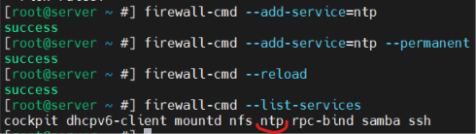
I keep pool the same in /etc/chrony.d. I just need to uncomment this:
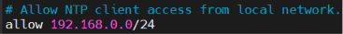
Let’s set ntp true and restart service:

Client Side
We should install the same package in Client Side, too:
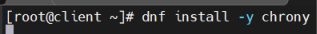
Service enable and start:
We need to add ntp to firewall:
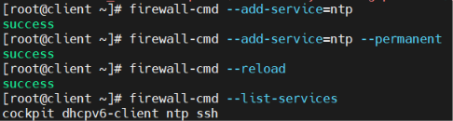
In `/etc/chrony.conf` file we need to write this line (ip is server’s ip):
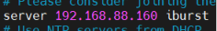
We set true ntp and restart the service:
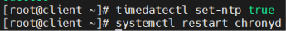
Let’s check it in client:
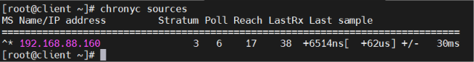
Because there is `*`, it means everything works well.

